The research questions asked by the participants were as follows:
- How old was Mary Stuart when she became queen of Scotland?
  - 16 years old
  - 10 years old
  - 6 days old
  - Other age
  - She never became Queen

- True or false: Mary Queen of Scots was accused of murdering her second husband?
  - True
  - False

- In what year did Mary Queen of Scots come to the Scottish throne?
  - 1601
  - 1542
  - 1845
  - 1907
  - Other year

- How long, if at all, was Mary Queen of Scots imprisoned for?
  - 25 years
  - 6 months
  - 19 years
  - 20 Years
  - Other time

- What was Mary’s (Queen of Scots) iconic hair colour?
  - Brown
  - Black
  - Red/ginger
  - Blonde
  - Other hair colour

- Who was Mary Queen of Scots' well-known cousin?
  - Queen Victoria
  - Queen Elizabeth I
  - Henry VIII
  - Queen Elizabeth II
  - Someone else

- Which member of her Mary Queen of Scots family imprisoned her, if any?
  - Her Father
  - Her Uncle
  - Her Cousin
  - Her Husband
  - Other family member

- How many children did Mary Queen of Scots have?
  - 0
  - 1
  - 2
  - 3
  - 4+

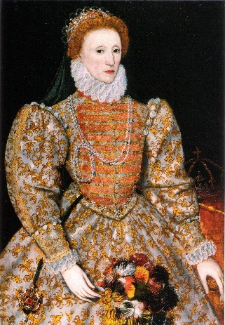
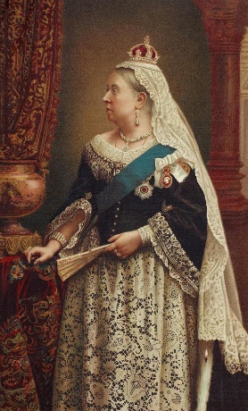
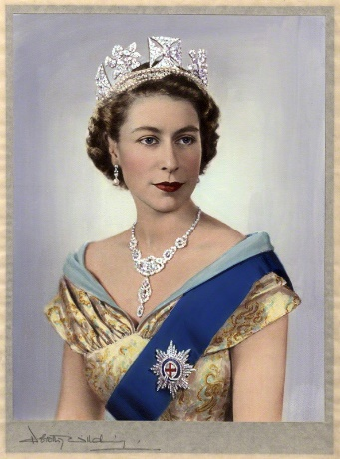
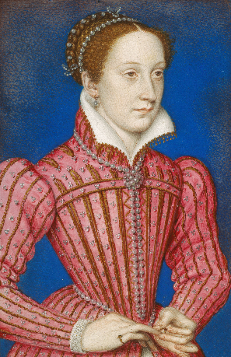
- Which of the following monarchs, if any, is Mary Queen of Scots?

- How old was Mary Queen of Scots when she was executed?
  - 20 years old
  - 50 years old
  - 44 years old
  - 35 years old
  - Other age

Answers to questions
1. C, 2. A, 3. B, 4. C, 5. C, 6. B, 7. C, 8. B, 9. B, 10. C,

