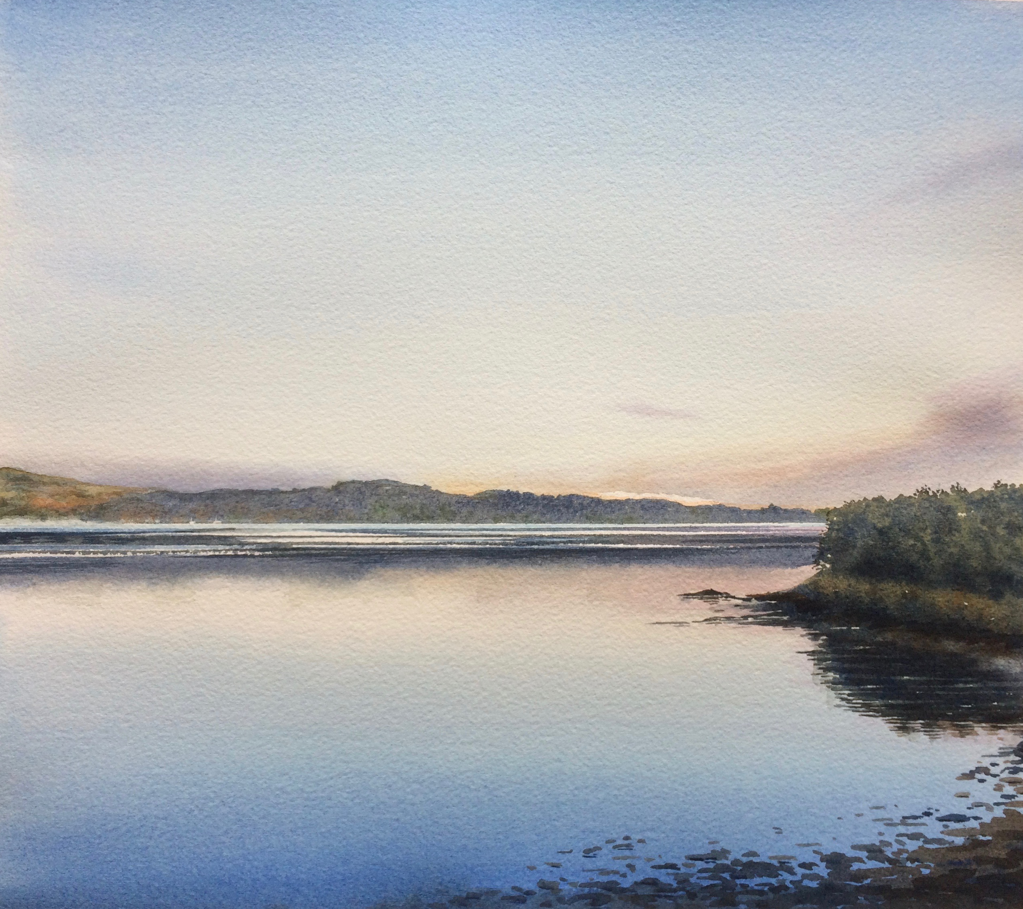
A R T I S T S T A T E M E N T

Serene light, gentle colours in a calm space, mists drifting, playing with distant horizons - I feel the need to capture arresting views and share them. The elusive goal is to recreate the moment that stopped you in your tracks, the scene that made you just look and stay looking.

I think artists have an important role to play in this fast moving technological world, where attention spans are short and images last for micro seconds, so if sharing an arresting image increases people’s awareness of earth’s infinite beauty, maybe it will stir people to slow down and feel more protective towards the planet, for future generations to enjoy.

Since moving to Devon my practice is evolving and naturally reflecting the local environment: seascapes, particularly estuary scenes at dawn or dusk; and in contrast the blurred, panoramic horizons of Dartmoor, where skies are big and weather conveys emotion in dramatic relief. The visual drama or mood may be the factor that people notice first, but a successful picture always has good tonal values underpinning it, and the composition draws you in, keeping the viewer’s eye travelling around the picture.

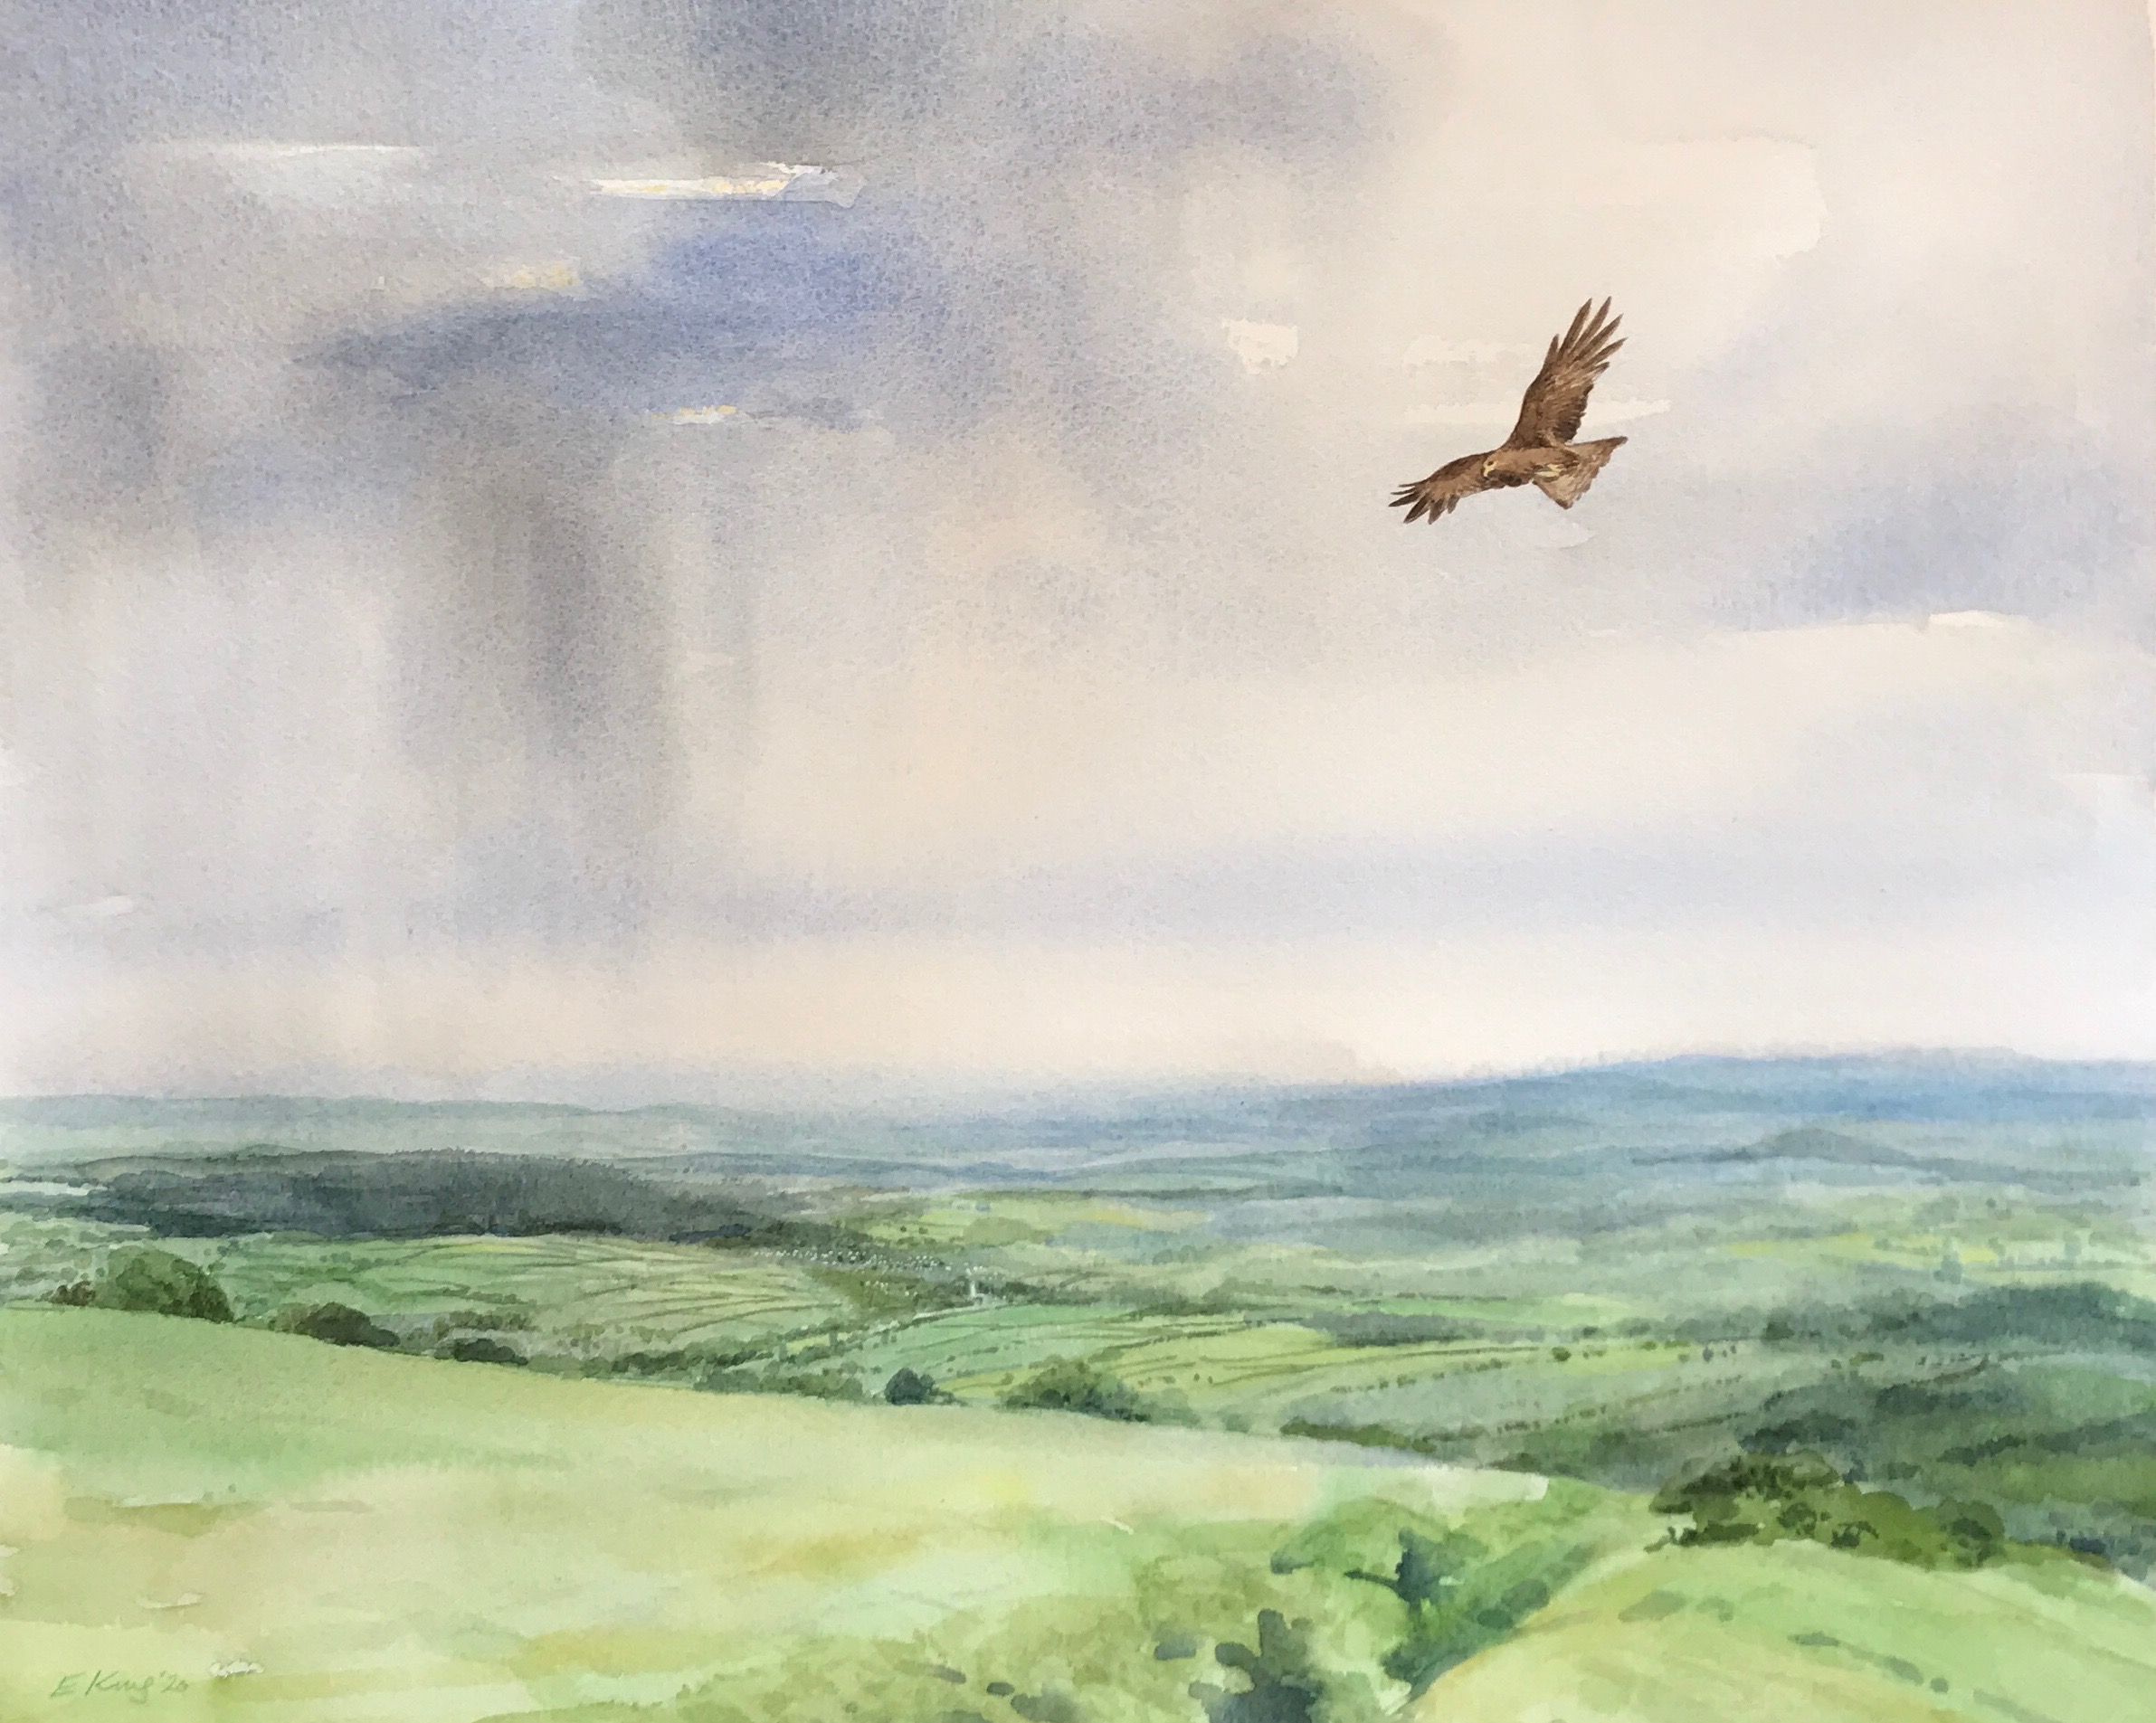
The serendipitous nature of watercolour suits both dynamic skies and still, reflecting waters and these two elements can make or break a painting. The distant showers depicted in ‘Red Kite over Dartmoor’ are a good example. This painting won two awards in The Artist magazine’s Open Competition, part of the Patching’s 2020 Festival. The exhibition award for 2021 means I shall explore the theme further, though I haven’t yet decided whether to focus on Dartmoor’s wildlife, perhaps around endangered, extinction issues, or stick to a more familiar theme of the Moor’s ever changing weather. Either way I’m excited by the challenge.

